Adaptive ICU Patient Deterioration Prediction using Temporal Deep Learning and Explainable AI
FINAL YEAR
PROJECT PHASE-I REPORT
Submitted by
Kovendhan.C (23619216)
Kanmani.K.U (23619213)
Mohamed Anas.M (23619220)
in Partial fulfillment for the award of the degree of
B. TECH - COMPUTER SCIENCE AND ENGINEERING
IN
ARTIFICIAL INTELLIGENCE AND MACHINE LEARNING


DEPARTMENT OF ARTIFICIAL INTELLIGENCE AND MACHINE LEARNING
SCHOOL OF ENGINEERING
VELS INSTITUTE OF SCIENCE, TECHNOLOGY AND ADVANCED STUDIES
(VISTAS)
CHENNAI
OCTOBER 2026

BONAFIDE CERTIFICATE

Certified that this project report “Adaptive ICU Patient Deterioration Prediction using Temporal Deep Learning and Explainable AI”, is the Bonafide work of KOVENDHAN C-23619216, KANMANI K U-23619213, MOHAMED ANAS M-23619220 carried out the project under my supervision. Certified further, that to the best of my knowledge the work reported here does not form part of any other project report or dissertation on the basis of which a degree or award was conferred on an earlier occasion on this or any other candidate.

SIGNATURE OF THE HOD SIGNATURE OF THE SUPERVISOR
Dr. K. Ulaga Priya M.E., Ph. D Dr.G.Revathy, M.E., ph. D.,
Associate Professor & Head Assistant Professor
Department of AI&ML Department of AI&ML
School of Engineering School of Engineering
VISTAS VISTAS
Chennai Chennai

Submitted for the Project Work and Viva-Voce examination held on ……………
at Vels Institute of Science, Technology and Advanced Studies (VISTAS), Chennai – 600 117.

INTERNAL EXAMINER EXTERNAL EXAMINER

ACKNOWLEDGEMENT

It is certainly a great delight and proud privilege to acknowledge the help and support I received from the positive minds around me in making this venture a successful one. The infrastructural support with all kinds of lab facilities have been a motivating factor in this completion of project work, all because of the FOUNDER & CHAIRMAN, Shri. Dr. ISHARI K. GANESH., with great pleasure that I take this opportunity to thank him. I am grateful to our HEAD OF THE DEPARTMENT, Dr. K.Ulaga Priya M.E.,Ph.D, , for her continuous support for the project, from initial advice and contacts in the early stages of conceptual inception, and through on-going advice and encouragement to this day. I extend our warmest thanks to my INTERNAL GUIDE, Dr.G.REVATHY M.E.,Ph.D, who has patiently guided and provided us with invaluable advice and help. I am thankful to my Project Coordinator Ms.S.M.Sowmiya, I would like to express my greatest gratitude to our Staff members, Librarian, and Non-teaching staff members of Computer Centre, who have helped and supported me throughout. Last but not the Least, I wish to thank my parents and my friends for their individual support and interest who has inspired me and encouraged me to go in my own way, without them I would be unable to complete this project.

KOVENDHAN C- 23619216
KANMANI K U- 23619213
MOHAMED ANAS M- 23619220
TABLE OF CONTENTS
CHAPTER NO. |  |  | TITLE | PAGE NO.
 |  |  | Abstract | 9
1 |  |  | INTRODUCTION | 11
 | 1.1 |  | Overview | 11
 | 1.2 |  | Problem Statement | 11
 | 1.3 |  | Objective | 12
 | 1.4 |  | Modules | 12
 | 1.5 |  | Summary | 12
2 |  |  | LITERATURE SURVEY | 13
 | 2.1 |  | Overview | 13
 | 2.2 |  | Existing System | 13
 | 2.3 |  | Literature Survey | 13
 |  | 2.3.1 | Research Gap | 14
 |  | 2.3.2 | Proposed System | 14
 | 2.4 |  | Summary | 14
3 |  |  | METHODOLOGY | 15
 | 3.1 |  | System Architecture | 15
 | 3.2 |  | Description of Modules | 16
 | 3.3 |  | Data Collection | 16
 | 3.4 |  | Data Preprocessing | 17
 |  | 3.4.1 | Missing Value Handling | 17
 |  | 3.4.2 | Leakage Prevention | 17
 | 3.5 |  | Feature Engineering | 18
 | 3.6 |  | Train, Test & Split | 18
 |  | 3.6.1 | Class Imbalance | 18
 | 3.7 |  | Deterioration Prediction Models | 19
 |  | 3.7.1 | Logistic Regression | 19
 |  | 3.7.2 | Random Forest | 19
 |  | 3.7.3 | XGBoost | 19
 |  | 3.7.4 | LSTM | 19
 |  | 3.7.5 | GRU | 19
 |  | 3.7.6 | SHAP Explainability | 19
 | 3.8 |  | Evaluation Metrics | 20
 | 3.9 |  | Summary | 20
4 |  |  | SYSTEM IMPLEMENTATION | 21
 | 4.1 |  | Overview | 21
 | 4.2 |  | System Requirements | 21
 | 4.3 |  | System Workflow | 22
 |  | 4.3.1 | Dashboard Components | 23
 | 4.4 |  | Module Implementation | 23
 |  | 4.4.1 | Data Collection Module | 23
 |  | 4.4.2 | Preprocessing Module | 23
 |  | 4.4.3 | Feature Engineering Module | 23
 |  | 4.4.4 | Sequence Generation Module | 23
 |  | 4.4.5 | Model Training Module | 24
 |  | 4.4.6 | Adaptive Risk Prediction Module | 24
 |  | 4.4.7 | Explainable AI Module | 24
 |  | 4.4.8 | Evaluation Module | 24
 |  | 4.4.9 | Dashboard Module | 24
 |  | 4.4.10 | Implementation Challenges | 25
 |  | 4.4.11 | Testing Strategy | 26
 | 4.5 |  | Summary | 26
5 |  |  | EXPERIMENTAL ANALYSIS | 27
 | 5.1 |  | Experimental Setup | 27
 |  | 5.1.1 | Experimental Considerations | 27
 | 5.2 |  | Performance Evaluation | 27
 |  | 5.2.1 | 6-Hour XGBoost Result | 28
 |  | 5.2.2 | 12-Hour XGBoost Result | 28
 |  | 5.2.3 | 24-Hour GRU Result | 29
 |  | 5.2.4 | Result Table Interpretation | 29
 |  | 5.2.5 | Performance Summary | 30
 | 5.3 |  | Comparison with Existing Work | 30
 |  | 5.3.1 | Relation to Reviewed Research | 31
 | 5.4 |  | Result & Discussion | 31
 | 5.5 |  | Summary | 32
6 |  |  | CONCLUSION AND FUTURE WORK | 33
 | 6.1 |  | Conclusion | 33
 | 6.2 |  | Limitations of Current Work | 33
 | 6.3 |  | Future Enhancement | 33
 | 6.4 |  | Summary | 34
7 |  |  | REFERENCES | 35
8 |  |  | SOURCE CODE | 36-45
9 |  |  | CONFERENCE DETAILS | 46

LIST OF FIGURES

FIGURE NO. | FIGURE NAME | PAGE NO.
3.1 | Overall architecture of the proposed system. | 14
4.1 | Proposed workflow for ICU risk prediction using clinical data | 21
5.1 | ROC-AUC for 6-hour patient deterioration prediction | 28
5.2 | ROC-AUC for 12-hour patient deterioration prediction | 28
5.3 | ROC-AUC for 24-hour patient deterioration prediction | 29

LIST OF TABLES

TABLE NO. | TABLE NAME | PAGE NO.
2.1 | Literature Survey | 13
3.1 | Description of Modules | 15
3.2 | Data Collection Attributes and Details | 15
3.3 | Feature Groups and Their Role in Prediction | 17
3.4 | Evaluation Metrics and Their Interpretation | 18
4.1 | Software Requirements | 20
4.2 | Hardware Requirements | 20
4.3 | Testing Strategy | 25
5.1 | Experimental Setup and Configuration | 26
5.2 | Performance Evaluation Results | 27
5.3 | Performance Summary | 29
5.4 | Comparison with Existing Work | 29

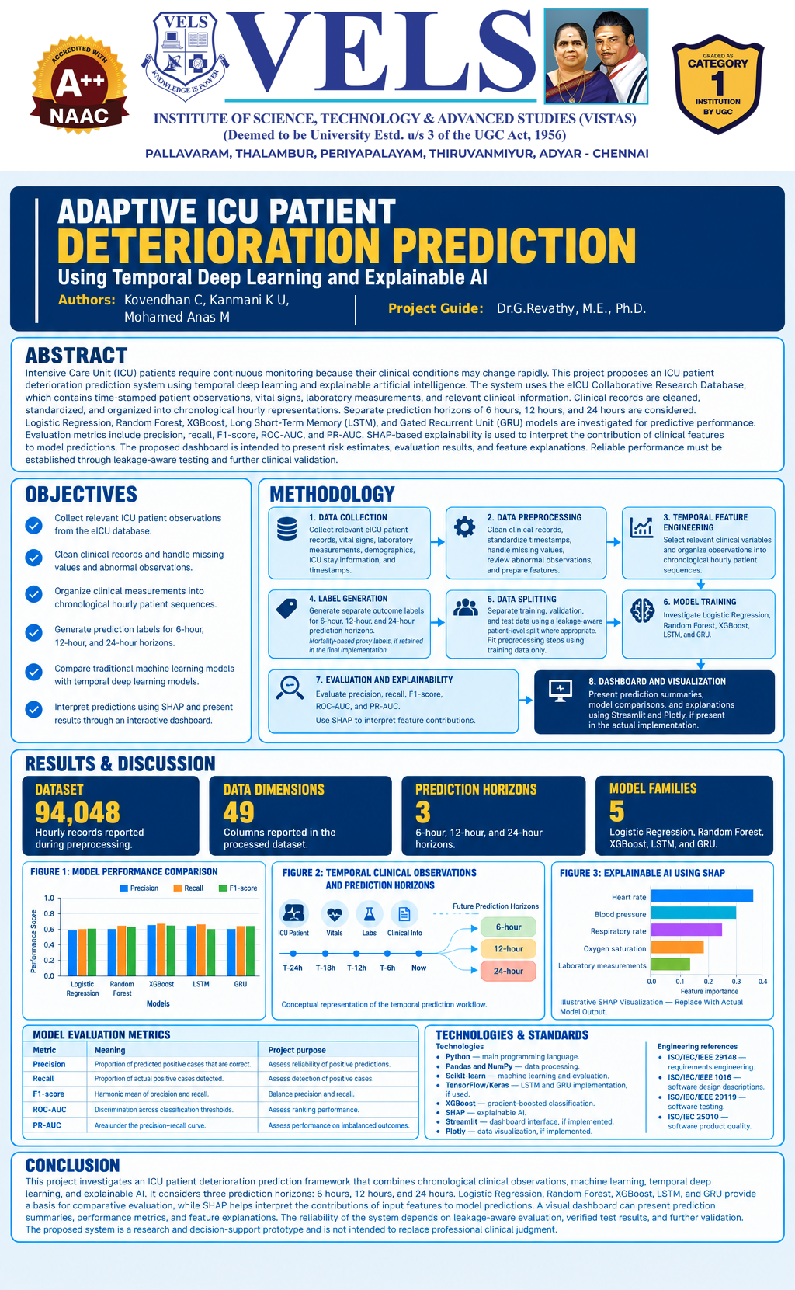

Abstract
Patient condition can get worse slowly in an intensive care unit, but it's not always easy to detect this early on. A machine that can look at a patient's records can give an early sign that the patient needs more attention. This paper introduces an adaptive system for predicting patient deterioration in the ICU. It uses scientific time series data from the eICU Collaborative Research Database. The system uses patient details, vital signs, lab results, treatment information, and other medical observations. The data is cleaned, organized by patient and time, and transformed into a standard format for machine learning. Logistic Regression and Random Forest are used as baseline methods, while XGBoost is the main machine learning model. A GRU-based time-series model is also used for comparison. The prediction is made for 6-hour, 12-hour, and 24-hour time frames. The system uses accuracy, F1-score, and ROC-AUC for evaluation, along with visual analysis through confusion matrices and ROC curves. Explainable AI is used via SHAP to show which clinical factors contributed to a prediction. The output isn't a diagnosis but a risk estimate that can be shown on a medical dashboard to help healthcare professionals make decisions.

Keywords: ICU deterioration prediction, eICU Collaborative Research Database, temporal deep learning, LSTM, GRU, XGBoost, explainable artificial intelligence, SHAP, clinical decision support.

CHAPTER 1
INTRODUCTION

1.1 OVERVIEW
An Intensive Care Unit is a high-dependency clinical environment in which patients require continuous observation because their physiological condition can change rapidly. ICU information is generated from several sources, including bedside monitors, laboratory investigations, medication records, neurological assessments, nursing observations, and treatment-related information. These observations are not always collected at the same frequency, and many variables contain missing or irregular measurements.
Patient deterioration is often not represented by one abnormal value. It may appear as a combination of changes in heart rate, blood pressure, oxygen saturation, respiratory rate, temperature, neurological status, and laboratory measurements. A model that considers the temporal sequence of these observations can therefore provide a different form of decision support from a system that only analyses a single snapshot.
Artificial intelligence and machine learning provide methods for learning relationships between historical clinical observations and future outcomes. Classical algorithms such as Logistic Regression, Random Forest, and XGBoost can identify non-linear patterns in structured data. Recurrent neural networks such as Long Short-Term Memory (LSTM) and Gated Recurrent Unit (GRU) are designed to process sequences and can capture temporal dependencies across multiple observations.
However, predictive performance alone is not sufficient for a healthcare-oriented system. A model may produce a high-risk prediction without explaining which clinical factors contributed to the result. Explainable AI techniques such as SHAP can make the prediction more transparent by estimating the contribution of each input feature.
The proposed project therefore combines clinical data preprocessing, multi-horizon deterioration prediction, machine learning, temporal deep learning, SHAP-based explanation, and a dashboard interface into one software framework.

1.2 PROBLEM STATEMENT
ICU deterioration can develop over time and may not be recognised early enough using conventional monitoring alone. The volume of clinical observations makes continuous manual interpretation difficult, while irregular sampling and missing measurements make direct modelling challenging.
Existing predictive studies may focus on a particular outcome such as mortality or sepsis and may not provide a complete software workflow for broader deterioration risk. In addition, different forecasting horizons can behave differently, so a model that performs well at one horizon cannot automatically be assumed to be optimal at another.
A further challenge is interpretability. Healthcare professionals need supporting evidence when reviewing an AI-generated risk estimate. A system that presents only a probability without an explanation may be difficult to trust or investigate.
Therefore, the problem addressed in this project is the development of an end-to-end, time-aware, explainable software system that can process ICU observations, estimate deterioration risk at multiple horizons, compare machine-learning and temporal deep-learning approaches, and present the output in an understandable dashboard.
1.3 OBJECTIVE

The main objective of the project is to develop an AI-based early-warning system for predicting ICU patient deterioration from longitudinal clinical observations. The system aims to convert irregular ICU records into usable temporal representations and estimate deterioration risk over 6-hour, 12-hour and 24-hour future horizons. It compares Logistic Regression, Random Forest, XGBoost, LSTM and GRU approaches while reducing patient-level and temporal data leakage during preprocessing and evaluation. Model performance is assessed using Precision, Recall, F1-score and ROC-AUC, supported by appropriate visual analyses. SHAP-based explanations are incorporated to identify the clinical features contributing to selected predictions, and an interactive dashboard is developed for patient selection, risk presentation, temporal trends and model explanations.

1.4 MODULES
Module 1: Data Collection & Preprocessing
Collect and organise ICU observations from the eICU Collaborative Research Database.
Clean data, handle missing values, check abnormal records, align time, and prepare model-ready inputs.
Module 2: Feature Engineering & Temporal Sequence Generation
Select clinically relevant variables and construct numerical and temporal features.
Arrange observations chronologically and create horizon-specific input sequences.
Module 3: Model Development
Train classical machine-learning and temporal deep-learning models.
Module 4: Adaptive Risk Prediction & Explainable AI
Generate deterioration probabilities and map predictions to risk categories for dashboard display.
Use SHAP to show positive and negative feature contributions.
Module 5: Evaluation & Visualisation
Calculate evaluation metrics and prepare plots, tables, and dashboard views.

1.5 SUMMARY
This chapter introduced the ICU deterioration problem, the motivation for temporal prediction, the role of machine learning and deep learning, the need for explainability, and the objectives and modules of the proposed project. The next chapter reviews related research and identifies the gap addressed by the proposed framework.

CHAPTER 2
LITERATURE SURVEY

2.1 OVERVIEW
Machine learning has been increasingly applied to critical-care data for predicting mortality, sepsis, deterioration, length of stay, and other clinically important outcomes. Early studies commonly used statistical and tree-based models, while later work increasingly adopted recurrent neural networks to exploit temporal information.
The literature reviewed for this project also demonstrates that model performance depends on the outcome definition, dataset, prediction window, feature representation, and evaluation metric. A high ROC-AUC does not necessarily mean that the model will achieve high Recall or F1-score at a selected classification threshold.
Explainability is another important consideration. In a healthcare setting, a prediction should ideally be accompanied by information that helps a user understand which variables contributed to the risk estimate. This motivates the integration of SHAP in the proposed system
.

2.2 EXISTING SYSTEM
Existing ICU prediction systems can be broadly grouped into conventional machine-learning systems and temporal deep-learning systems. Conventional systems use engineered variables such as vital signs, laboratory results, demographics, and clinical scores. Their advantages include relatively simple training and easier feature inspection.
Temporal deep-learning systems process sequences of observations using architectures such as LSTM and GRU. They can learn temporal dependencies without requiring every relationship to be manually engineered. However, they require carefully prepared sequences, greater computational resources, and more attention to temporal leakage.
Many published studies are designed around a particular endpoint such as mortality or sepsis. While these outcomes are clinically important, a practical early-warning platform can benefit from a broader deterioration-oriented formulation and a user interface that integrates predictions and explanations.

2.3 LITERATURE SURVEY

AUTHORS / YEAR | STUDY | METHODOLOGY | REPORTED RESULT | LIMITATION
M. Mili et al. (2023) | ICU Mortality Prediction using Long Short-Term Memory Networks | Clinical time-series preprocessing, missing-value handling and LSTM modelling. | Reported useful performance for selected prediction settings. | Focused on mortality and a specific dataset; interpretability and dashboard integration were not the main focus.
J. Wang et al. (2025) | Dynamic Real-Time Risk Prediction for ICU Mortality Using Time-Aware Bi-LSTM | Time-aware ICU sequence modelling using a bidirectional LSTM approach. | Reported ROC-AUC around 0.90 in the study context. | Mortality-focused and not designed as the complete ML + XAI + dashboard workflow used here.
H. A. Aly et al. (2022) | E-CatBoost using the eICU Collaborative Research Database | eICU data with Logistic Regression, Random Forest and CatBoost-type boosting methods. | Reported strong classification performance in the study. | Primarily structured ML; temporal representation and integrated XAI
F. Ahmed et al. (2023) | Early Prediction of Sepsis in Intensive Care Patients Using Machine Learning | Feature engineering and machine-learning methods for early sepsis prediction. | Reported useful ROC-AUC performance. | Sepsis-specific rather than broader ICU deterioration; limited focus on temporal DL and dashboard explanation.
R. Vashisht et al. (2015) | ICU Patient Deterioration Prediction: A Data Mining Approach | Decision Tree, Logistic Regression and Random Forest approaches. | Reported useful deterioration classification performance. | Traditional ML and older data-mining approach; lacks modern temporal DL and integrated XAI.
Table 2.1 Literature Survey

2.3.1 RESEARCH GAP
The literature and project review identify several important research gaps. Existing work does not always integrate multiple prediction horizons within one end-to-end software workflow, and comparisons between classical machine learning and temporal deep learning are often performed under different preprocessing strategies. The combination of deterioration prediction with patient-level SHAP explanations and the integration of prediction, explanation, trends and patient selection into a single dashboard are also limited. In addition, explicit attention to patient-level leakage, irregular sampling, missingness and class imbalance remains important for developing a reliable ICU prediction system.

2.3.2 PROPOSED SYSTEM
The proposed system addresses the identified gap by using the eICU Collaborative Research Database as the data source and constructing a common pipeline for preprocessing, temporal sequence generation, multi-horizon prediction, model evaluation, SHAP explanation, and dashboard presentation. Classical machine-learning models provide structured baselines, while LSTM and GRU provide temporal comparisons. The system is designed so that model performance is discussed separately for each prediction horizon rather than combined into one overall score.

2.4 SUMMARY
The literature survey shows a progression from traditional ICU classification methods toward temporal neural networks and real-time risk prediction. It also highlights the importance of evaluation choices and interpretability. The proposed system builds on these ideas by combining multi-horizon prediction, model comparison, SHAP explanations, and a clinical dashboard.

CHAPTER 3
METHODOLOGY

3.1 SYSTEM ARCHITECTURE
The proposed architecture follows a sequential data-to-decision pipeline. The eICU database is first converted into a structured patient-level dataset. Data collection is followed by cleaning, imputation, scaling or numerical preparation, feature selection, and temporal sequence creation. The resulting data is partitioned into training and evaluation subsets using a leakage-aware strategy. Classical ML models and deep-learning models are then trained and evaluated. The selected outputs are passed to the explainability layer, and the risk score and explanations are presented through the clinical dashboard.

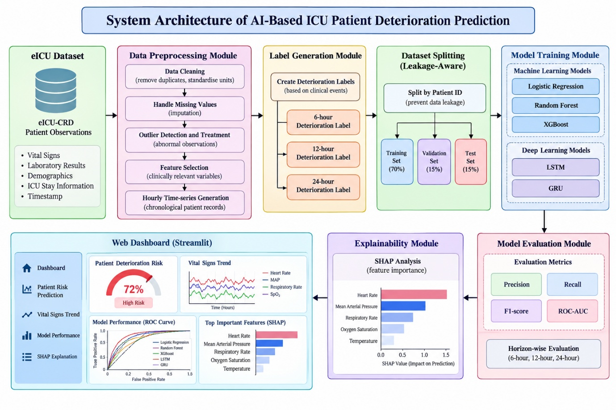
Figure 3.1 Overall architecture of the proposed system.

3.2 DESCRIPTION OF MODULES
MODULE | DETAILED IMPLEMENTATION
Data Collection | The data collection module identifies the ICU records required for modelling. The project uses the eICU Collaborative Research Database and considers vital signs, laboratory values, demographic/context information, medication-related observations and other available clinical variables.
Data Preprocessing | The preprocessing module checks data types, removes unusable records, handles missing observations, checks abnormal values, and organises records chronologically. Preprocessing objects are fitted using training data where applicable to avoid information leakage.
Feature Engineering | Feature engineering converts raw clinical observations into variables suitable for modelling. Important variables include Heart Rate, Blood Pressure, SpO₂, Respiratory Rate, Temperature, GCS and laboratory measurements. Temporal summaries can represent recent values, changes, or trends.
Temporal Sequence Generation | The sequence-generation module sorts records by patient and time and constructs hourly representations. Prediction horizons are defined as 6 hours, 12 hours and 24 hours after the observation window.
Model Development | The project compares Logistic Regression, Random Forest and XGBoost for structured learning and LSTM and GRU for temporal learning.
Adaptive Risk Prediction | The prediction module converts model probabilities into a patient-level deterioration risk output. The dashboard presents risk categories such as Low, Moderate and High as a decision-support representation rather than a clinical diagnosis.
Explainable AI | SHAP estimates the contribution of individual features to a prediction. Features with positive contributions push the prediction toward higher risk, while negative contributions push it toward lower risk.
Evaluation and Visualization | The evaluation module computes Precision, Recall, F1-score and ROC-AUC and prepares supporting charts, tables and dashboard visualisations.
Table 3.1 Description of Modules

3.3 DATA COLLECTION

ATTRIBUTE | DETAIL
Dataset | eICU Collaborative Research Database
Source | PhysioNet / eICU research database
Data type | Multi-centre ICU clinical data
Reported preprocessed size | 138,953 rows × 47 columns
Reported further processed size | 94,049 rows × 47 columns
Main data groups | Vitals, laboratory measurements, medications, demographic/context and clinical observations
Prediction horizons | 6 hours, 12 hours and 24 hours
Table 3.1 1Data Collection Attributes and Details

The supplied project materials report 138,953 rows and 47 columns for a preprocessed dataset and 94,049 rows and 47 columns after further processing. These values are retained as project-reported dataset characteristics. The report does not assign the reduction to one single cleaning operation because the supplied materials do not provide a complete row-by-row audit of every filtering step.
eICU Collaborative Research Database: https://physionet.org/content/eicu-crd/

3.4 DATA PRE-PROCESSING
Data cleaning begins by identifying the relevant eICU tables and variables required for the modelling task. Duplicate or unusable records are removed where appropriate, and numerical fields are checked for invalid, extreme or clinically impossible values. Missing observations are handled using an approach consistent with the variable type and training pipeline. Patient and ICU-stay identifiers are preserved so that grouping and leakage checks remain possible, and the resulting observations are sorted chronologically before temporal sequences are constructed.

3.4.1 MISSING VALUE HANDLING
Missingness is common in ICU data because not every test is performed for every patient at every time point. The absence of a laboratory result, for example, does not necessarily indicate a normal physiological state. Therefore, the preprocessing strategy must distinguish between a missing measurement and an actual measured value. The selected imputation or carry-forward strategy must be fitted only on training information when the transformation is learned from data.

3.4.2 PATIENT-LEVEL DATA LEAKAGE PREVENTION
Patient-level leakage occurs when information from a patient that should belong only to the evaluation stage influences model training. In a time-series setting, leakage can also occur when future measurements are accidentally included in the input sequence used to predict the past or present. The project therefore treats leakage prevention as a central preprocessing requirement.

3.5 FEATURE ENGINEERING

FEATURE GROUP | ROLE IN PREDICTION
Heart Rate | Represents cardiovascular response and may provide information through absolute values and temporal changes.
Blood Pressure | Provides information about haemodynamic status and changes in perfusion-related measurements.
SpO₂ | Represents oxygenation status and can contribute to respiratory deterioration detection.
Respiratory Rate | Represents respiratory stress and its temporal progression.
Temperature | Provides physiological and infection-related context.
GCS | Provides information about neurological status and changes in consciousness.
Laboratory Measurements | Add biochemical and physiological evidence not available from bedside vital signs alone.
Demographic / Context Variables | Provide patient-level context where permitted by the prediction pipeline.
Table 3.3 Feature Groups and Their Role in Prediction

3.6 TRAIN,TEST & SPLIT
The dataset is divided into training and testing sets to evaluate the performance and generalisation capability of the proposed ICU patient deterioration prediction model. The training dataset is used to train the machine learning algorithms by learning patterns from patient vital signs, laboratory results, demographic information, and other clinically relevant variables. The testing dataset is kept separate from the training process and is used to assess the model’s predictive performance on unseen patient data. To prevent data leakage, the dataset is split using a patient-level approach, ensuring that records belonging to the same patient do not appear in both the training and testing sets. This approach helps avoid overly optimistic performance estimates caused by overlapping patient information. The training and testing datasets are then used to evaluate the model using appropriate performance metrics, including accuracy, precision, recall, F1-score, and ROC-AUC. This data-splitting strategy supports a more reliable and realistic assessment of the model’s ability to predict patient deterioration within the ICU.

3.6.1 CLASS IMBALANCE
Deterioration events can be much less frequent than non-deterioration events. This creates class imbalance and can make Accuracy appear better than the actual ability to detect positive cases. For this reason, the project gives particular attention to Recall and F1-score alongside ROC-AUC. Future experiments can additionally investigate class weights, resampling, threshold optimisation and precision-recall curves.

3.7 DETERIORATION PREDICTION MODELS

3.7.1 LOGISTIC REGRESSION
Logistic Regression provides a transparent baseline for binary classification. It estimates the probability of the deterioration class from the prepared features. It is useful as a reference model because it provides a relatively simple relationship between input variables and the predicted probability.

3.7.2 RANDOM FOREST
Random Forest combines multiple decision trees and aggregates their predictions. It can model non-linear relationships and interactions between structured clinical variables and is less dependent on linear assumptions.

3.7.3 XGBOOST
XGBoost is the main classical machine-learning model used in the project. It builds an ensemble of gradient-boosted decision trees and is well suited to structured tabular data. In this project it operates on the prepared clinical representation and produces a deterioration probability that can be evaluated across multiple horizons.

3.7.4 LSTM
Long Short-Term Memory is a recurrent neural network architecture designed to retain useful information across sequential observations. It uses gated memory mechanisms to learn temporal relationships and is appropriate for clinical time-series data where recent and earlier observations may jointly influence the future risk.

3.7.5 GRU
Gated Recurrent Unit is another recurrent architecture for sequence modelling. It uses a simpler gating structure than LSTM and can therefore be computationally efficient while still learning temporal dependencies. The reported 24-hour result in this project uses GRU.

3.7.6 SHAP EXPLAINABILITY
SHAP, or SHapley Additive exPlanations, is used after prediction to estimate how individual input features contribute to the model output. A positive SHAP contribution indicates that the feature pushes the prediction toward the target class, while a negative contribution moves it in the opposite direction. SHAP explanations improve transparency but should not be interpreted as proof of causality.

3.8 EVALUATION METRICS

METRIC | FORMULA / INTERPRETATION
Accuracy | (TP + TN) / (TP + TN + FP + FN). Overall proportion of correct classifications.
Precision | TP / (TP + FP). Proportion of predicted deterioration cases that are actually positive.
Recall | TP / (TP + FN). Proportion of actual deterioration cases that are detected.
F1-score | 2 × Precision × Recall / (Precision + Recall). Harmonic mean of Precision and Recall.
ROC-AUC | Measures the ability of the model to rank positive cases above negative cases across classification thresholds.
Table 3.4 Evaluation Metrics and Their Interpretation

3.9 SUMMARY
This chapter described the technical methodology of the proposed ICU deterioration prediction system. It covered the software and hardware requirements, system architecture, modules, dataset, preprocessing, feature engineering, temporal sequence construction, leakage prevention, class imbalance, prediction models, explainability, evaluation metrics, and the complete end-to-end methodology.

CHAPTER 4
SYSTEM IMPLEMENTATION

4.1 OVERVIEW
The implementation stage converts the methodology into an operational software pipeline. The system is organised into data preparation, model execution, explanation, evaluation, and dashboard layers.The implementation is designed so that the same clinical observations can be prepared consistently before being passed to different model families. This makes it possible to compare classical machine learning and temporal deep learning while maintaining a common data foundation.

4.2 SYSTEM REQUIREMENT

SOFTWARE REQUIREMENTS
COMPONENT | REQUIREMENT
Operating System | Windows 10/11 or Linux
Programming Language | Python 3.10 or above
Development Environment | Jupyter Notebook / Google Colab / VS Code
Data Processing | Pandas, NumPy
Machine Learning | Scikit-learn and XGBoost
Deep Learning | LSTM and GRU implementation using a deep-learning framework
Explainable AI | SHAP
Visualization | Matplotlib and dashboard charting components
Dashboard Layer | React / Node.js based interface as specified in the project design
Database Layer | PostgreSQL-compatible application layer as specified in the project design
Table 4.1 Software Requirements

HARDWARE REQUIREMENTS
COMPONENT | REQUIREMENT
Processor | Intel Core i5 / AMD Ryzen 5 or above
RAM | 8 GB minimum; 16 GB recommended
Storage | At least 20–50 GB free working space
GPU | Optional for classical ML; NVIDIA GPU recommended for faster recurrent-model training
Network | Internet connection for dataset access and cloud development environments
Table 4.2 Hardware Requirements

4.3 SYSTEM WORKFLOW
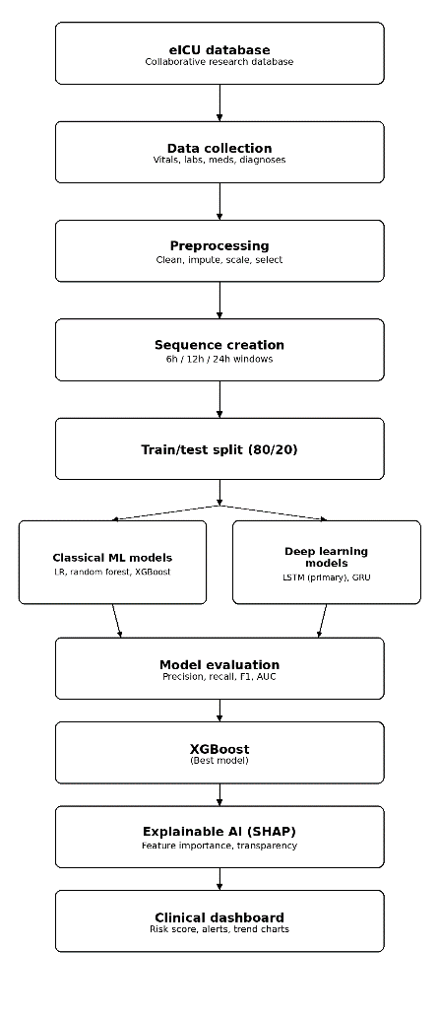
Fig 2. Proposed workflow for ICU risk prediction using clinical data

The platform is designed around a patient-centric dashboard. A user selects or searches for an ICU patient and can view risk estimates for the supported forecasting horizons. The interface can display the patient's recent information, selected vital-sign trends, and an explanation of the model output. This structure is intended to reduce the cognitive effort required to interpret a model result.

4.3.1 DASHBOARD COMPONENTS
The dashboard is organised around patient-centred information. It supports patient search or selection and presents the patient's available clinical context together with 6-hour, 12-hour and 24-hour risk cards. Risk categories and probabilities are displayed clearly, while recent vital-sign trends provide temporal context. SHAP feature-contribution visualisations help explain the prediction, and higher-risk cases can be presented in an alert-oriented manner. The interface should also clearly state that the system provides decision support and does not constitute a clinical diagnosis.

4.4 MODULE IMPLEMENTATION

4.4.1 DATA COLLECTION MODULE
The data collection module identifies the relevant eICU tables and fields required for modelling. The system is designed to retain patient identifiers, ICU-stay identifiers and timestamps so that observations can be aligned and grouped correctly.

4.4.2 PREPROCESSING MODULE
The preprocessing module is responsible for cleaning the raw clinical data. It performs data-type conversion, missing-value handling, removal of unsuitable records, numerical preparation, and temporal ordering. A key implementation principle is that transformations learned from the data must be fitted only on training information before being applied to validation or test information.

4.4.3 FEATURE ENGINEERING MODULE
The feature engineering module converts raw observations into model-ready variables. Vital signs such as Heart Rate, Blood Pressure, SpO₂, Respiratory Rate and Temperature are important inputs. GCS and laboratory variables add neurological and physiological information. Temporal representations can additionally capture changes rather than only absolute measurements.

4.4.4 SEQUENCE GENERATION MODULE
The sequence generation module converts chronological observations into hourly representations. Separate target-generation logic is used for each forecast horizon. This prevents the 6-hour target from being treated as equivalent to the 24-hour target and supports horizon-specific evaluation.

4.4.5 MODEL TRAINING MODULE
The model training layer contains separate workflows for Logistic Regression, Random Forest, XGBoost, LSTM and GRU. The classical models work with the engineered tabular representation, while the recurrent models receive ordered sequences. The training process records model configuration, preprocessing configuration, and evaluation results so that experiments can be reproduced.

4.4.6 ADAPTIVE RISK PREDICTION MODULE
The prediction layer converts the selected model's probability into a risk presentation for the dashboard. The term adaptive refers to the horizon-specific and patient-specific nature of the prediction rather than a claim that the system automatically changes its clinical policy. Risk categories should be treated as interface labels and not as clinical diagnoses.

4.4.7 EXPLAINABLE AI MODULE
The SHAP layer receives the model and the selected prediction input and produces feature contributions. The dashboard can sort features according to their absolute contribution so that the user can quickly identify which variables most influenced the risk estimate.

4.4.8 EVALUATION MODULE
The evaluation layer generates a standard set of metrics for each horizon and model. ROC curves are useful for understanding ranking performance, while Recall and F1-score provide additional information about positive-case detection at the selected threshold.

4.4.9 DASHBOARD MODULE
The dashboard is the final presentation layer. It combines patient information, risk estimates, temporal trends and explanations. A clinical user should be able to move from patient selection to risk interpretation without manually inspecting the underlying machine-learning outputs.
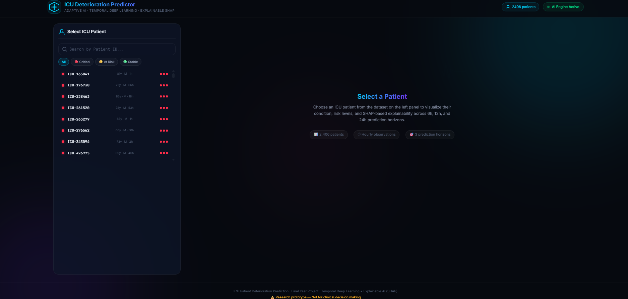

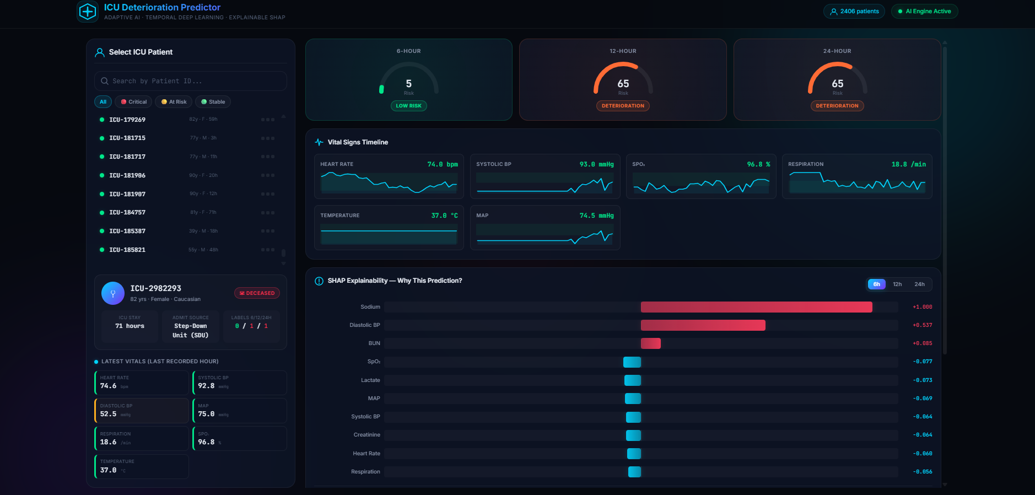

MPLEMENTATION CHALLENGES
Implementation was affected by several practical challenges. The eICU database contains many tables and variables, making relevant-field identification time-consuming, while clinical observations are recorded at irregular intervals and missing measurements are common. The deterioration label must clearly separate historical input information from future target information, and class imbalance makes positive-event detection difficult. Recurrent models also require additional computation and careful sequence preparation. Patient-level leakage can produce overly optimistic results if it is not explicitly controlled, and different prediction horizons can produce substantially different performance patterns.

4.4.11 TESTING STRATEGY
TEST AREA | CHECK
Data integrity | Check nulls, duplicates, invalid values and expected columns.
Temporal integrity | Verify chronological ordering and no future observations in input sequences.
Patient separation | Verify that evaluation patients are not unintentionally included in training.
Model output | Check probability range, class labels and expected prediction shape.
Metric calculation | Verify F1, Recall and ROC-AUC against confusion-matrix values / prediction arrays.
Explainability | Check that SHAP output corresponds to the selected model input.
Dashboard | Verify patient selection, risk cards, charts and explanation rendering.
Table 4.3 Testing Strategy

4.5 SUMMARY
This chapter described how the proposed methodology is translated into a software implementation. The implementation integrates data processing, sequence generation, model training, risk prediction, SHAP explanation, evaluation and dashboard presentation into one coherent workflow.

CHAPTER 5
EXPERIMENTAL ANALYSIS

5.1 EXPERIMENTAL SETUP
The experiments are based on the eICU Collaborative Research Database and the preprocessing and modelling pipeline described in the previous chapters. The reported project configuration includes Python-based data processing, XGBoost for structured machine learning, LSTM and GRU for temporal deep learning, SHAP for explainability, and visualisation/dashboard components for result presentation.
ITEM | EXPERIMENTAL CONFIGURATION
Dataset | eICU Collaborative Research Database
Reported processed data | 138,953 × 47 and 94,049 × 47 at successive processing stages
Forecast horizons | 6 hours, 12 hours and 24 hours
Classical ML | Logistic Regression, Random Forest, XGBoost
Temporal DL | LSTM, GRU
Explainability | SHAP
Evaluation | Precision, Recall, F1-score, ROC-AUC
Presentation | Charts and clinical dashboard
Table 5.1 Experimental Setup and Configuration

5.1.1 EXPERIMENTAL CONSIDERATIONS
The experimental analysis reports performance separately for each prediction horizon because the behaviour of a model may change as the forecasting window changes. ROC-AUC is used to evaluate ranking and discrimination across thresholds, while F1-score and Recall provide additional information about positive-case detection at the selected classification threshold. Because deterioration events can be imbalanced, Accuracy alone is not sufficient for interpretation. Results from different horizons are therefore not combined into a single model ranking. Threshold optimisation, class weighting and probability calibration remain important areas for future investigation.

5.2 PERFORMANCE EVALUATION
The following values are the final reported results available in the project materials. The report deliberately does not invent missing Accuracy values or unreported model/horizon combinations.
PREDICTION HORIZON | MODEL | F1-SCORE | RECALL | ROC-AUC
6 hours | XGBoost | 0.0317 | 0.0741 | 0.8740
12 hours | XGBoost | 0.0781 | 0.1754 | 0.8390
24 hours | GRU | 0.1366 | 0.1818 | 0.7214
Table 5.2 Performance Evaluation Results

5.2.1 6-HOUR XGBOOST RESULT
For the 6-hour prediction horizon, the reported XGBoost experiment achieved a ROC-AUC of 0.8740, F1-score of 0.0317 and Recall of 0.0741. The ROC-AUC indicates comparatively strong ranking/discrimination performance, while the low Recall and F1-score show that positive-case detection at the reported classification operating point is limited. This difference is important in an imbalanced clinical prediction problem.
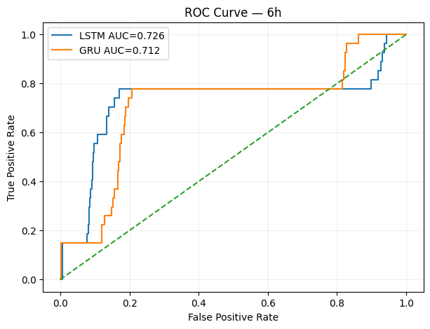
Fig 3. ROC Curve Analysis for 6-Hour Patient Deterioration Prediction

5.2.2 12-HOUR XGBOOST RESULT
For the 12-hour horizon, XGBoost achieved a ROC-AUC of 0.8390, F1-score of 0.0781 and Recall of 0.1754. Compared with the 6-hour result, the F1-score and Recall are higher while ROC-AUC is lower. This demonstrates that different evaluation metrics can move in different directions when the prediction horizon and operating conditions change.
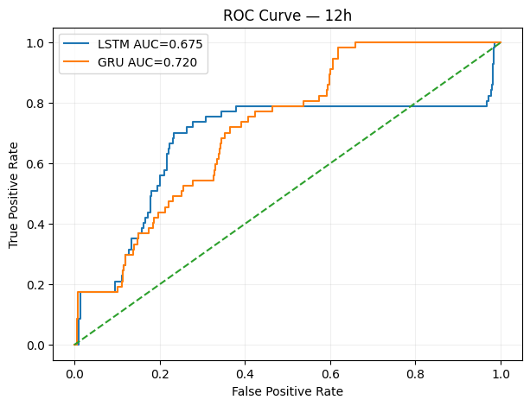
Fig 4. ROC Curve Analysis for 12-Hour Patient Deterioration Prediction

5.2.3 24-HOUR GRU RESULT
For the 24-hour horizon, the reported GRU experiment achieved F1-score 0.1366, Recall 0.1818 and ROC-AUC 0.7214. Among the three reported result rows, this is the highest F1-score and Recall. However, its ROC-AUC is lower than the XGBoost values reported for 6 and 12 hours. Therefore, the result should be interpreted as a horizon-specific trade-off rather than as evidence that GRU is universally superior to XGBoost.
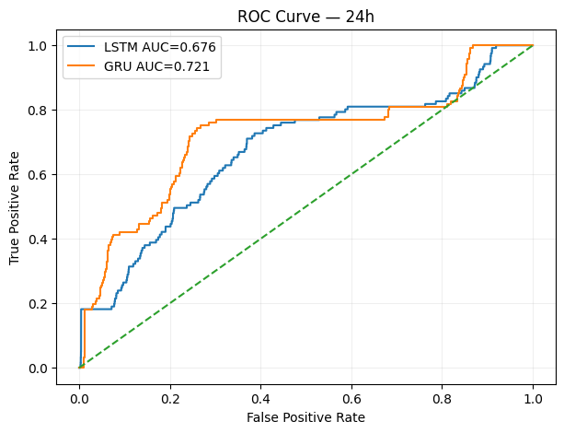
Fig 5. ROC Curve Analysis for 24-Hour Patient Deterioration Prediction

5.2.4 RESULT TABLE INTERPRETATION
The results cannot be treated as a single model ranking because the models are reported at different prediction horizons. A model can achieve a high ROC-AUC while producing lower Recall at the threshold used for the reported classification metrics. In an ICU application, this means that threshold selection, class weighting, calibration, and the intended clinical use case should be considered before selecting a deployment model.

5.2.5 PERFORMANCE SUMMARY
MEASURE | BEST REPORTED VALUE | MODEL / HORIZON | INTERPRETATION
ROC-AUC | 0.8740 | XGBoost / 6 hours | Highest reported discrimination value among the supplied final results.
F1-score | 0.1366 | GRU / 24 hours | Highest reported balance of Precision and Recall among the supplied final results.
Recall | 0.1818 | GRU / 24 hours | Highest reported positive-case retrieval among the supplied final results.
Table 5.3 Performance Summary

5.3 COMPARISON WITH EXISTING WORK
ASPECT | EXISTING APPROACHES | PROPOSED PROJECT
Primary objective | Often mortality or disease-specific prediction | ICU deterioration risk
Prediction horizon | Study-specific | 6h, 12h, 24h
Model families | ML or DL depending on study | ML + temporal DL
Temporal processing | Varies | Hourly / sequence-based representation
Explainability | Not always integrated | SHAP
User interface | Not always provided | Clinical dashboard prototype
Leakage consideration | Study-specific | Explicit patient/time leakage checks
Evaluation | Study-specific metrics | F1, Recall, ROC-AUC with horizon-specific analysis
Table 5.4 Comparison with Existing Work

5.3.1 RELATION TO REVIEWED RESEARCH
The reviewed literature supports the use of recurrent architectures for ICU time-series data and highlights the importance of preserving temporal information rather than treating observations as independent rows. Research using eICU data also supports the use of strong tabular machine-learning approaches such as gradient boosting, while studies on sepsis and deterioration demonstrate the value of early prediction and the importance of defining the target event carefully. Building on these findings, the proposed project combines multi-horizon prediction, SHAP-based explanation and dashboard presentation within a single software workflow.

5.4 RESULT & DISCUSSION
The project results demonstrate that model performance is strongly dependent on the prediction horizon and evaluation metric. The 6-hour XGBoost experiment has the highest reported ROC-AUC, while the 24-hour GRU experiment has the highest reported F1-score and Recall among the supplied final results.
The low F1 and Recall values indicate that identifying positive deterioration events remains difficult at the selected classification operating points. This is consistent with the class-imbalance challenge common in clinical prediction, where the positive class may be much smaller than the negative class.
The difference between ROC-AUC and threshold-dependent metrics highlights the importance of threshold selection. A model can rank positive cases relatively well but still classify too few cases as positive at a particular threshold. Future experiments should therefore examine precision-recall curves, threshold optimisation and probability calibration.
The temporal models provide a way to represent changes in patient state. The GRU result at 24 hours indicates that sequence modelling can be useful for longer-horizon prediction, although additional controlled experiments are needed before drawing general conclusions about model superiority.
The SHAP component improves transparency by showing the contribution of individual variables to the prediction. For example, the project materials use vital-sign changes such as elevated Heart Rate and reduced SpO₂ as illustrative examples of features that can influence risk. These explanations should be interpreted as model behaviour rather than causal clinical conclusions.
The dashboard improves practical usability by bringing together the risk estimate, prediction horizon, patient context, trends and feature contributions. This reduces the need for a user to inspect raw model outputs separately.

STRENGTHS
The project has several practical strengths. It uses a multi-centre ICU research database, supports multiple prediction horizons, and compares conventional machine-learning methods with temporal deep-learning models. The methodology explicitly considers patient-level data leakage and includes SHAP-based explainability to improve interpretation. The integrated dashboard brings prediction, patient context, trends and explanations into one interface, while the use of multiple evaluation metrics provides a more informative assessment than relying on Accuracy alone.

LIMITATIONS
The experimental interpretation is subject to several limitations. Only the supplied final result rows are available, so a complete model-by-horizon performance matrix is not included. Numeric Accuracy values, complete confusion-matrix counts and full ROC-curve coordinates are also unavailable in the supplied final result table. The exact deterioration-event label definition is not fully documented in the supplied materials. Furthermore, the dashboard is a research prototype rather than a clinically validated medical device, and external or prospective clinical validation has not yet been established.

5.5 SUMMARY
The experimental analysis demonstrates horizon-dependent model behaviour. XGBoost has the strongest reported ROC-AUC for the 6-hour and 12-hour experiments, while GRU has the strongest reported F1-score and Recall for the 24-hour experiment. The results reinforce the need for multi-metric, horizon-specific evaluation and careful threshold selection.
CHAPTER 6
CONCLUSION AND FUTURE WORK

6.1 CONCLUSION
This project presented an Adaptive ICU Patient Deterioration Prediction System that integrates clinical data preprocessing, machine learning, temporal deep learning, Explainable AI and dashboard-based decision support. The system uses the eICU Collaborative Research Database and is designed to estimate deterioration risk over 6-hour, 12-hour and 24-hour horizons.
The project addresses practical challenges associated with ICU data, including irregular sampling, missing observations, class imbalance and patient-level data leakage. The methodology organises clinical observations into time-aware representations and compares both structured machine-learning and recurrent deep-learning approaches.
The final reported results demonstrate that performance varies with the prediction horizon. XGBoost achieved ROC-AUC values of 0.8740 and 0.8390 for the 6-hour and 12-hour experiments, respectively. GRU achieved the highest reported F1-score and Recall among the supplied results at 24 hours, with values of 0.1366 and 0.1818.
The inclusion of SHAP provides an additional layer of interpretability by identifying the features that contribute to a prediction. The dashboard combines these explanations with patient information and risk estimates so that the output can be inspected more easily.
Overall, the project demonstrates a complete healthcare AI software pipeline from clinical data to temporal prediction and explainable presentation. The system should be regarded as a decision-support research prototype and not as a replacement for clinical expertise.

6.2 LIMITATION OF CURRENT WORK
The current work is based on retrospective data rather than prospective clinical deployment, and only a subset of the complete model-by-horizon results is available in the final reported table. The deterioration-label definition and classification-threshold configuration require further formal validation. Missing and irregular observations may influence model stability, while class imbalance can limit positive-event detection at some operating points. The dashboard remains a research prototype and is not integrated with a live hospital information system. In addition, SHAP explanations describe model behaviour and feature contribution rather than proving clinical causality. External validation on an independent ICU dataset or hospital population is still required.

6.3 FUTURE ENHANCEMENT
Future development should evaluate every model at every prediction horizon using an identical experimental protocol so that comparisons are more reliable. Additional work should investigate class weighting, focal loss, resampling and other methods for handling class imbalance, together with probability-threshold optimisation and calibration based on the intended clinical decision objective. Precision-recall curves, confidence intervals and calibration curves can provide a more complete evaluation. Future experiments may also examine Transformer and attention-based temporal architectures, hybrid models that combine boosting with temporal representations, and improved temporal features based on trends, variability and rates of change. External validation using independent ICU datasets is important before any broader clinical interpretation. The system can also be extended toward real-time streaming with secure data ingestion, authentication, role-based access, audit logging and encryption. Finally, clinician-centred usability studies and prospective evaluation would be required to assess practical usefulness.

6.4 SUMMARY
The proposed project establishes a foundation for an explainable ICU deterioration early-warning system. The main future requirement is not simply a more complex model, but a more reliable and clinically validated pipeline that combines calibrated prediction, robust temporal modelling, transparent explanations, secure deployment and prospective evaluation.

CHAPTER 7
REFERENCES
[1] M. Mili, A. Kerkeni, A. Ben Abdallah, and M. H. Bedoui, “ICU Mortality Prediction using Long Short-Term Memory Networks,” 2023.
[2] J. Wang, X. Zhao, X. Chen, et al., “Development and Validation of a Dynamic Real-Time Risk Prediction Model for Intensive Care Unit Mortality Using Time-Aware Bidirectional LSTM,” 2025.
[3] H. A. Aly, M. A. Elhoseny, et al., “E-CatBoost: An Efficient Machine Learning Framework for Predicting ICU Mortality Using the eICU Collaborative Research Database,” 2022.
[4] F. Ahmed, A. M. Kassem, et al., “Early Prediction of Sepsis in Intensive Care Patients Using Machine Learning,” 2023.
[5] R. Vashisht, B. Jung, et al., “ICU Patient Deterioration Prediction: A Data Mining Approach,” 2015.
[6] T. J. Pollard, A. E. W. Johnson, J. D. Raffa, et al., “The eICU Collaborative Research Database, a Freely Available Multi-Centre Database for Critical Care Research,” Scientific Data, vol. 5, 2018.
[7] T. Chen and C. Guestrin, “XGBoost: A Scalable Tree Boosting System,” Proceedings of the 22nd ACM SIGKDD International Conference on Knowledge Discovery and Data Mining, 2016.
[8] K. Cho et al., “Learning Phrase Representations using RNN Encoder–Decoder for Statistical Machine Translation,” Proceedings of EMNLP, 2014.
[9] S. M. Lundberg and S.-I. Lee, “A Unified Approach to Interpreting Model Predictions,” Advances in Neural Information Processing Systems, 2017.
[10] J. Chung, C. Gulcehre, K. Cho, and Y. Bengio, “Empirical Evaluation of Gated Recurrent Neural Networks on Sequence Modeling,” 2014.
Note: bibliographic details are limited to the information available in the supplied project materials. Additional DOI, volume, issue and page information should be verified against the final source documents before institutional submission.

CHAPTER 8

SOURCE CODE

from docx import Document
from docx.shared import Inches, Pt, Cm, RGBColor
from docx.enum.text import WD_ALIGN_PARAGRAPH
from docx.enum.table import WD_TABLE_ALIGNMENT
from docx.oxml.ns import qn

doc = Document()

# -- Page margins --
for section in doc.sections:
section.top_margin = Cm(2)
section.bottom_margin = Cm(2)
section.left_margin = Cm(2.5)
section.right_margin = Cm(2.5)

style = doc.styles['Normal']
font = style.font
font.name = 'Calibri'
font.size = Pt(11)

# ── Helper functions ──
def add_heading_styled(text, level=1):
h = doc.add_heading(text, level=level)
for run in h.runs:
run.font.color.rgb = RGBColor(0x1A, 0x1A, 0x2E)
return h

def add_table_row(table, cells_data, bold=False, bg_color=None):
row = table.add_row()
for i, text in enumerate(cells_data):
cell = row.cells[i]
cell.text = ''
p = cell.paragraphs[0]
run = p.add_run(str(text))
run.font.size = Pt(9)
if bold:
run.bold = True
run.font.color.rgb = RGBColor(0xFF, 0xFF, 0xFF)
if bg_color:
shading = cell._element.get_or_add_tcPr()
shading_elm = shading.makeelement(qn('w:shd'), {
qn('w:fill'): bg_color,
qn('w:val'): 'clear'
})
shading.append(shading_elm)
return row

def make_table(headers, rows, header_color='1A1A2E'):
table = doc.add_table(rows=1, cols=len(headers))
table.style = 'Table Grid'
table.alignment = WD_TABLE_ALIGNMENT.CENTER
# Header row
hdr = table.rows[0]
for i, text in enumerate(headers):
cell = hdr.cells[i]
cell.text = ''
p = cell.paragraphs[0]
run = p.add_run(text)
run.bold = True
run.font.size = Pt(9)
run.font.color.rgb = RGBColor(0xFF, 0xFF, 0xFF)
shading = cell._element.get_or_add_tcPr()
shading_elm = shading.makeelement(qn('w:shd'), {
qn('w:fill'): header_color,
qn('w:val'): 'clear'
})
shading.append(shading_elm)
# Data rows
for row_data in rows:
add_table_row(table, row_data)
return table

title = doc.add_heading('ICU Patient Deterioration Prediction', level=0)
for run in title.runs:
run.font.color.rgb = RGBColor(0x1A, 0x1A, 0x2E)
run.font.size = Pt(22)

subtitle = doc.add_heading('Feature Documentation — Priority List', level=1)
for run in subtitle.runs:
run.font.color.rgb = RGBColor(0x44, 0x44, 0x66)
run.font.size = Pt(14)

doc.add_paragraph('')
info = doc.add_paragraph()
info.add_run('Dataset: ').bold = True
info.add_run('eicu_hourly_labeled_6h_12h_24h.csv\n')
info.add_run('Source: ').bold = True
info.add_run('eICU Collaborative Research Database\n')
info.add_run('Total Records: ').bold = True
info.add_run('~94,049 hourly observations\n')
info.add_run('Total Columns: ').bold = True
info.add_run('48')

add_heading_styled('Overview', 1)
doc.add_paragraph(
'This document lists all features used in the ICU Patient Deterioration Prediction project, '
'ordered by priority/importance based on the model\'s SHAP-derived feature weights and clinical '
'relevance for predicting patient deterioration at 6-hour, 12-hour, and 24-hour horizons.'
)

add_heading_styled('Feature Categories', 2)
make_table(
['Category', 'Count', 'Description'],
[
['Vital Signs (Time-Series)', '7', 'Continuous physiological measurements recorded hourly'],
['Laboratory Values (Time-Series)', '9', 'Blood test results updated periodically'],
['Demographic & Administrative', '5', 'Static patient information'],
['Missingness Indicators', '16', 'Binary flags indicating imputed values'],
['Target Labels & Metadata', '8', 'Prediction targets and data splits (NOT used as inputs)'],
]
)

doc.add_page_break()
add_heading_styled('Priority 1 — Critical Predictors (Highest Importance)', 1)
p = doc.add_paragraph('These features have the ')
p.add_run('strongest influence').bold = True
p.add_run(' on deterioration prediction based on SHAP analysis.')

make_table(
['#', 'Feature', 'Type', 'Unit', 'Normal Range', 'Weight', 'Description'],
[
['1', 'sao2', 'Vital Sign', '%', '95–100', '1.8',
'Peripheral oxygen saturation (SpO₂). The single most important predictor — low SpO₂ strongly signals respiratory failure.'],
['2', 'Lactate', 'Lab Value', 'mmol/L', '0.5–2.0', '1.7',
'Blood lactate level. Elevated lactate indicates tissue hypoperfusion, sepsis, or shock.'],
['3', 'systemicmean', 'Vital Sign', 'mmHg', '70–105', '1.6',
'Mean Arterial Pressure (MAP). Critical indicator of organ perfusion. MAP < 65 mmHg signals septic shock.'],
['4', 'systemicsystolic', 'Vital Sign', 'mmHg', '90–140', '1.5',
'Systolic Blood Pressure. Hypotension (< 90 mmHg) is a red flag for hemodynamic instability.'],
['5', 'Creatinine', 'Lab Value', 'mg/dL', '0.6–1.2', '1.5',
'Serum creatinine. Rising creatinine indicates acute kidney injury (AKI).'],
],
header_color='C0392B'
)

add_heading_styled('Priority 2 — Important Predictors (High Importance)', 1)
doc.add_paragraph('These features significantly contribute to the model\'s predictions.')

make_table(
['#', 'Feature', 'Type', 'Unit', 'Normal Range', 'Weight', 'Description'],
[
['6', 'heartrate', 'Vital Sign', 'bpm', '60–100', '1.4',
'Heart rate. Tachycardia (> 100 bpm) or bradycardia (< 60 bpm) signals cardiovascular stress.'],
['7', 'respiration', 'Vital Sign', '/min', '12–20', '1.3',
'Respiratory rate. Tachypnea (> 20/min) is one of the earliest signs of deterioration and a qSOFA criterion.'],
['8', 'WBC', 'Lab Value', '×10³/µL', '4.5–11.0', '1.2',
'White Blood Cell count. Leukocytosis or leukopenia indicates infection/sepsis.'],
],
header_color='E67E22'
)

add_heading_styled('Priority 3 — Moderate Predictors', 1)
doc.add_paragraph('These features provide supporting information for prediction accuracy.')

make_table(
['#', 'Feature', 'Type', 'Unit', 'Normal Range', 'Weight', 'Description'],
[
['9', 'temperature', 'Vital Sign', '°C', '36.1–37.5', '1.1',
'Body temperature. Fever (> 38.3°C) or hypothermia (< 36°C) are SIRS criteria.'],
['10', 'BUN', 'Lab Value', 'mg/dL', '7–20', '1.1',
'Blood Urea Nitrogen. Elevated BUN reflects renal dysfunction and dehydration.'],
['11', 'systemicdiastolic', 'Vital Sign', 'mmHg', '60–90', '1.0',
'Diastolic Blood Pressure. Complements systolic BP in cardiovascular assessment.'],
['12', 'Potassium', 'Lab Value', 'mEq/L', '3.5–5.0', '1.0',
'Serum potassium. Both hypo- and hyperkalemia cause dangerous cardiac arrhythmias.'],
['13', 'Platelets', 'Lab Value', '×10³/µL', '150–400', '1.0',
'Platelet count. Thrombocytopenia is a component of DIC and sepsis coagulopathy.'],
],
header_color='F1C40F'
)

add_heading_styled('Priority 4 — Supporting Predictors (Lower Importance)', 1)
doc.add_paragraph('These features add supplementary context to the prediction model.')

make_table(
['#', 'Feature', 'Type', 'Unit', 'Normal Range', 'Weight', 'Description'],
[
['14', 'Hemoglobin', 'Lab Value', 'g/dL', '12–17', '0.9',
'Blood hemoglobin. Anemia (low Hgb) affects oxygen delivery and can worsen deterioration.'],
['15', 'Glucose', 'Lab Value', 'mg/dL', '70–140', '0.8',
'Blood glucose. Both hypoglycemia and hyperglycemia are associated with poor ICU outcomes.'],
['16', 'Sodium', 'Lab Value', 'mEq/L', '136–145', '0.7',
'Serum sodium. Dysnatremia affects neurological function and fluid balance.'],
],
header_color='27AE60'
)

doc.add_page_break()
add_heading_styled('Priority 5 — Demographic & Contextual Features', 1)
doc.add_paragraph('Static features providing patient background context.')

make_table(
['#', 'Feature', 'Type', 'Values/Range', 'Description'],
[
['17', 'age (age_numeric)', 'Demographic', 'Numeric (years)',
'Patient age. Older patients have higher baseline risk.'],
['18', 'gender (gender_encoded)', 'Demographic', 'Male / Female',
'Patient biological sex. Encoded as binary for the model.'],
['19', 'ethnicity', 'Demographic', 'Caucasian, African American, etc.',
'Patient ethnicity. Contextual demographic information.'],
['20', 'unitadmitsource', 'Administrative', 'ICU, ER, Floor, etc.',
'Source of ICU admission — indicates severity at entry.'],
['21', 'unitstaytype', 'Administrative', 'admit, readmit, stepdown',
'Type of ICU stay — readmissions may indicate higher risk.'],
],
header_color='2980B9'
)

add_heading_styled('Priority 6 — Missingness Indicator Features', 1)
doc.add_paragraph(
'Binary flags (0 or 1) indicating whether each corresponding feature value was imputed '
'(missing in the original record). Missingness itself can be clinically informative — '
'a test not ordered may indicate stability.'
)

missing_features = [
'heartrate', 'systemicsystolic', 'systemicdiastolic', 'systemicmean',
'respiration', 'sao2', 'temperature', 'WBC', 'Hemoglobin', 'Platelets',
'Creatinine', 'BUN', 'Sodium', 'Potassium', 'Glucose', 'Lactate'
]
missing_rows = [[str(i+22), f'{f}_missing', f] for i, f in enumerate(missing_features)]
make_table(['#', 'Missingness Feature', 'Original Feature'], missing_rows, header_color='7F8C8D')

add_heading_styled('Target Variables (NOT Used as Input Features)', 1)
p = doc.add_paragraph('These columns are ')
p.add_run('prediction targets').bold = True
p.add_run(' and metadata — they are ')
p.add_run('excluded').bold = True
p.add_run(' from model input to prevent data leakage.')

make_table(
['Column', 'Description'],
[
['label_6h', 'Binary — will the patient deteriorate within the next 6 hours?'],
['label_12h', 'Binary — will the patient deteriorate within the next 12 hours?'],
['label_24h', 'Binary — will the patient deteriorate within the next 24 hours?'],
['icu_death', 'Binary — did the patient die during the ICU stay?'],
['hours_to_event', 'Hours until deterioration event'],
['discharge_hour', 'Hour of ICU discharge'],
['unitdischargeoffset', 'Discharge offset in minutes'],
['split', 'Data split: train / val / test'],
],
header_color='95A5A6'
)

add_heading_styled('Feature Engineering in Model Pipeline', 1)
doc.add_paragraph(
'For classical ML models (Logistic Regression, Random Forest, XGBoost), '
'the following summary features are derived from each 24-hour time-series window:'
)

make_table(
['Derived Feature', 'Description'],
[
['Last Value', 'Most recent hourly reading for each feature'],
['Mean', 'Average value across the 24-hour observation window'],
['Standard Deviation', 'Variability/instability measure over 24 hours'],
['Linear Trend', 'Slope over time — captures worsening or improving trajectory'],
],
header_color='8E44AD'
)

doc.add_paragraph('')
note = doc.add_paragraph()
note.add_run('Note: ').bold = True
note.add_run(
'For deep learning models (LSTM, GRU), raw 24-hour sequences of all features '
'are used directly as input without summary feature engineering.'
)

add_heading_styled('Summary Statistics', 1)
make_table(
['Metric', 'Value'],
[
['Total columns in dataset', '48'],
['Input features (used by model)', '37'],
['Excluded columns (targets + metadata)', '8'],
['Identifier columns', '3'],
['Vital sign features', '7'],
['Lab value features', '9'],
['Demographic features', '5'],
['Missingness indicators', '16'],
]
)

output_path = r'c:\Users\LAPTOP\Downloads\database preproccesssing\Feature_List_Priority.docx'
doc.save(output_path)
print(f'Done! Document saved to: {output_path}')

CHAPTER 9

CONFERENCE DETAILS

